Life Management 2.0 (iOS Version)

Installation and Maintenance Guide

Author: Eric Rado

We recommend to use git source control in the following manner

1. First go to <https://desktop.github.com/> and download Github Desktop which was used by all team members



2. Once the download is complete open the application to check if installation was successful.

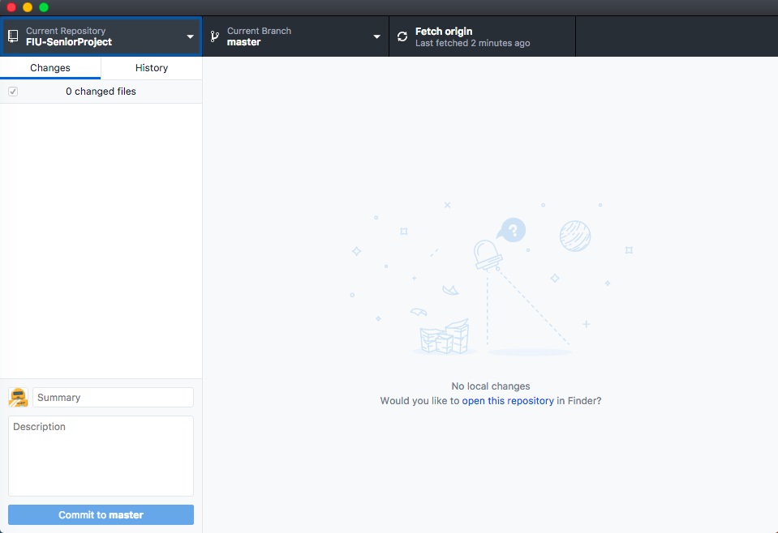

3. Now go to the FIU SCIS Senior Project Github repository and look for Life Management

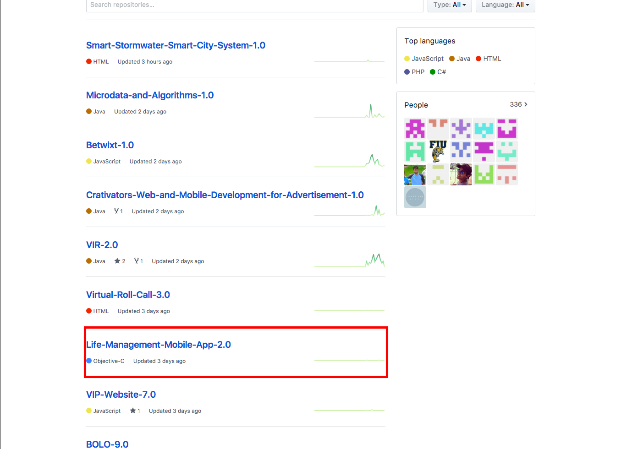

4. Once you're in the repository of Life Management click on Clone or Download and then click on open in Desktop

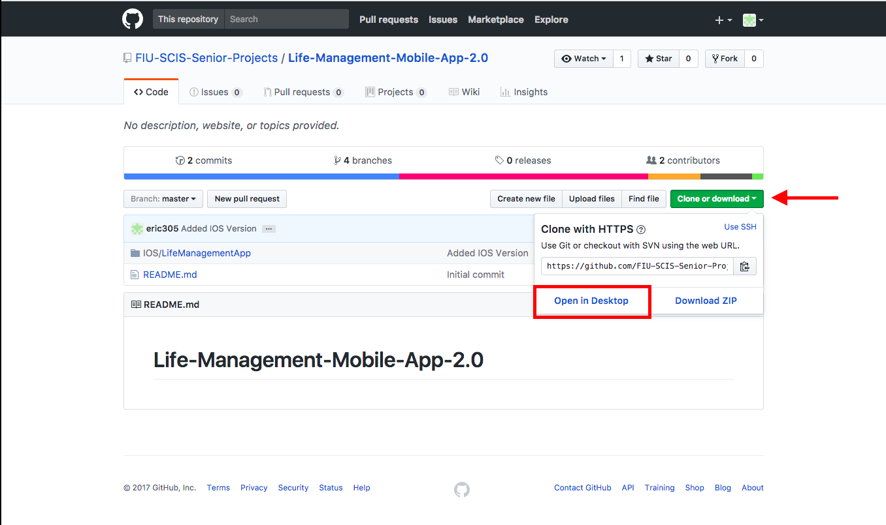

5. The following screen should be displayed. Click on choose to specify the location Github will clone the project too. Then click Clone.

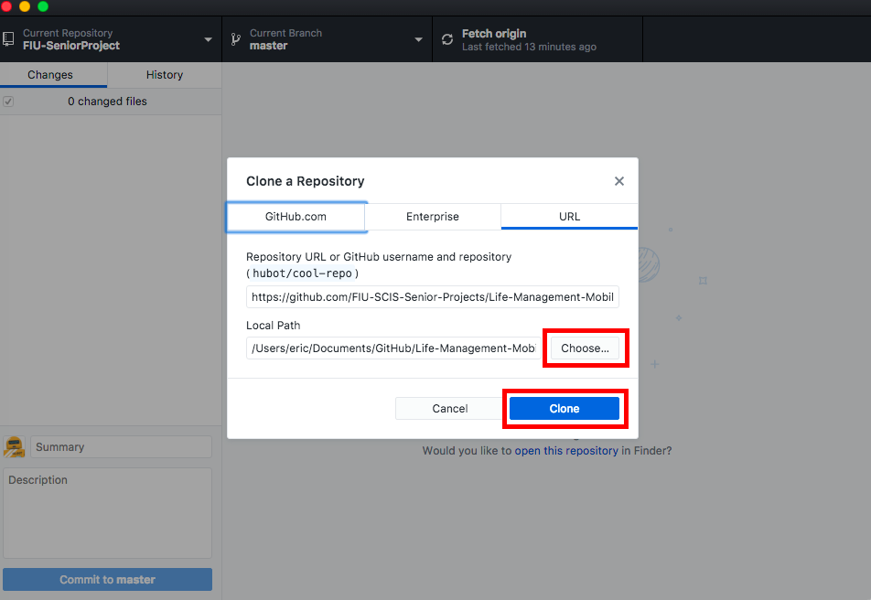

6.  Click on new branch when you are in master branch and give your new branch a name

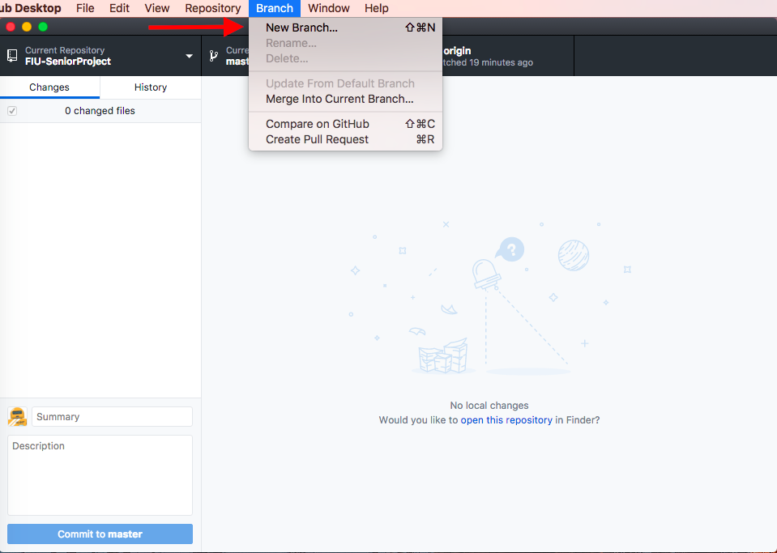

7. Once your done working on your branch go to master branch, then under the branch tab click on “Merge into Current Branch” then select the branch you want to merge to master

8. If you want to delete a branch go to the tab labeled “Branch” then click on Delete.

Once the project is cloned, no extra files is necessary to download because everything is included in the iOS project folder. The connection to the database is also included in the folder.